1st 6 Weeks Data for CSHS
Attendance
9th Grade | 97.6%
10th Grade | 97.4%
11th Grade | 97.2%
12th Grade | 98%
Grades
Course Type | Ethnicity | A | B | C | D | F | Total
1000 - English | American Indian | 0 | 2 | 0 | 0 | 0 | 2
1000 - English | American Indian | 0.0% | 100.0% | 0.0% | 0.0% | 0.0% | 100.0%
1000 - English | Asian | 89 | 31 | 8 | 2 | 3 | 133
1000 - English | Asian | 66.9% | 23.3% | 6.0% | 1.5% | 2.3% | 100.0%
1000 - English | Black | 57 | 56 | 18 | 19 | 17 | 167
1000 - English | Black | 34.1% | 33.5% | 10.8% | 11.4% | 10.2% | 100.0%
1000 - English | Hawian/Pacific Islander | 1 | 2 | 0 | 1 | 0 | 4
1000 - English | Hawian/Pacific Islander | 25.0% | 50.0% | 0.0% | 25.0% | 0.0% | 100.0%
1000 - English | Hispanic | 127 | 106 | 28 | 21 | 29 | 311
1000 - English | Hispanic | 40.8% | 34.1% | 9.0% | 6.8% | 9.3% | 100.0%
1000 - English | Multi-Ethnic | 31 | 16 | 3 | 1 | 4 | 55
1000 - English | Multi-Ethnic | 56.4% | 29.1% | 5.5% | 1.8% | 7.3% | 100.0%
1000 - English | White | 589 | 364 | 63 | 50 | 49 | 1,115
1000 - English | White | 52.8% | 32.6% | 5.7% | 4.5% | 4.4% | 100.0%
1000 - English | Econ Dis | 125 | 126 | 37 | 35 | 46 | 369
1000 - English | Econ Dis | 33.9% | 34.1% | 10.0% | 9.5% | 12.5% | 100.0%
1000 - English | Sped | 40 | 35 | 15 | 13 | 11 | 114
1000 - English | Sped | 35.1% | 30.7% | 13.2% | 11.4% | 9.6% | 100.0%
2000 - Math | American Indian | 1 | 1 | 0 | 0 | 0 | 2
2000 - Math | American Indian | 50.0% | 50.0% | 0.0% | 0.0% | 0.0% | 100.0%
2000 - Math | Asian | 86 | 36 | 9 | 5 | 2 | 138
2000 - Math | Asian | 62.3% | 26.1% | 6.5% | 3.6% | 1.4% | 100.0%
2000 - Math | Black | 35 | 60 | 30 | 21 | 11 | 157
2000 - Math | Black | 22.3% | 38.2% | 19.1% | 13.4% | 7.0% | 100.0%
2000 - Math | Hawian/Pacific Islander | 2 | 1 | 0 | 1 | 0 | 4
2000 - Math | Hawian/Pacific Islander | 50.0% | 25.0% | 0.0% | 25.0% | 0.0% | 100.0%
2000 - Math | Hispanic | 102 | 118 | 37 | 27 | 16 | 300
2000 - Math | Hispanic | 34.0% | 39.3% | 12.3% | 9.0% | 5.3% | 100.0%
2000 - Math | Multi-Ethnic | 31 | 14 | 5 | 2 | 2 | 54
2000 - Math | Multi-Ethnic | 57.4% | 25.9% | 9.3% | 3.7% | 3.7% | 100.0%
2000 - Math | White | 526 | 415 | 77 | 63 | 27 | 1,108
2000 - Math | White | 47.5% | 37.5% | 6.9% | 5.7% | 2.4% | 100.0%
2000 - Math | Econ Dis | 102 | 149 | 45 | 31 | 26 | 353
2000 - Math | Econ Dis | 28.9% | 42.2% | 12.7% | 8.8% | 7.4% | 100.0%
2000 - Math | Sped | 14 | 44 | 11 | 9 | 9 | 87
2000 - Math | Sped | 16.1% | 50.6% | 12.6% | 10.3% | 10.3% | 100.0%
3000 - Science | American Indian | 0 | 2 | 0 | 0 | 0 | 2
3000 - Science | American Indian | 0.0% | 100.0% | 0.0% | 0.0% | 0.0% | 100.0%
3000 - Science | Asian | 112 | 30 | 2 | 7 | 0 | 151
3000 - Science | Asian | 74.2% | 19.9% | 1.3% | 4.6% | 0.0% | 100.0%
3000 - Science | Black | 24 | 63 | 21 | 26 | 21 | 155
3000 - Science | Black | 15.5% | 40.6% | 13.5% | 16.8% | 13.5% | 100.0%
3000 - Science | Hawian/Pacific Islander | 0 | 2 | 0 | 2 | 0 | 4
3000 - Science | Hawian/Pacific Islander | 0.0% | 50.0% | 0.0% | 50.0% | 0.0% | 100.0%
3000 - Science | Hispanic | 89 | 103 | 42 | 32 | 27 | 293
3000 - Science | Hispanic | 30.4% | 35.2% | 14.3% | 10.9% | 9.2% | 100.0%
3000 - Science | Multi-Ethnic | 22 | 19 | 1 | 2 | 4 | 48
3000 - Science | Multi-Ethnic | 45.8% | 39.6% | 2.1% | 4.2% | 8.3% | 100.0%
3000 - Science | White | 568 | 326 | 90 | 59 | 43 | 1,086
3000 - Science | White | 52.3% | 30.0% | 8.3% | 5.4% | 4.0% | 100.0%
3000 - Science | Econ Dis | 89 | 114 | 52 | 42 | 45 | 342
3000 - Science | Econ Dis | 26.0% | 33.3% | 15.2% | 12.3% | 13.2% | 100.0%
3000 - Science | Sped | 10 | 23 | 12 | 18 | 13 | 76
3000 - Science | Sped | 13.2% | 30.3% | 15.8% | 23.7% | 17.1% | 100.0%
4000 - Social Studies | American Indian | 1 | 1 | 0 | 0 | 0 | 2
4000 - Social Studies | American Indian | 50.0% | 50.0% | 0.0% | 0.0% | 0.0% | 100.0%
4000 - Social Studies | Asian | 81 | 31 | 8 | 4 | 1 | 125
4000 - Social Studies | Asian | 64.8% | 24.8% | 6.4% | 3.2% | 0.8% | 100.0%
4000 - Social Studies | Black | 45 | 57 | 27 | 25 | 13 | 167
4000 - Social Studies | Black | 26.9% | 34.1% | 16.2% | 15.0% | 7.8% | 100.0%
4000 - Social Studies | Hawian/Pacific Islander | 2 | 0 | 2 | 0 | 0 | 4
4000 - Social Studies | Hawian/Pacific Islander | 50.0% | 0.0% | 50.0% | 0.0% | 0.0% | 100.0%
4000 - Social Studies | Hispanic | 121 | 99 | 34 | 37 | 13 | 304
4000 - Social Studies | Hispanic | 39.8% | 32.6% | 11.2% | 12.2% | 4.3% | 100.0%
4000 - Social Studies | Multi-Ethnic | 27 | 21 | 0 | 1 | 2 | 51
4000 - Social Studies | Multi-Ethnic | 52.9% | 41.2% | 0.0% | 2.0% | 3.9% | 100.0%
4000 - Social Studies | White | 611 | 307 | 65 | 66 | 18 | 1,067
4000 - Social Studies | White | 57.3% | 28.8% | 6.1% | 6.2% | 1.7% | 100.0%
4000 - Social Studies | Econ Dis | 124 | 124 | 44 | 47 | 23 | 362
4000 - Social Studies | Econ Dis | 34.3% | 34.3% | 12.2% | 13.0% | 6.4% | 100.0%
4000 - Social Studies | Sped | 32 | 33 | 5 | 18 | 4 | 92
4000 - Social Studies | Sped | 34.8% | 35.9% | 5.4% | 19.6% | 4.3% | 100.0%

Discipline
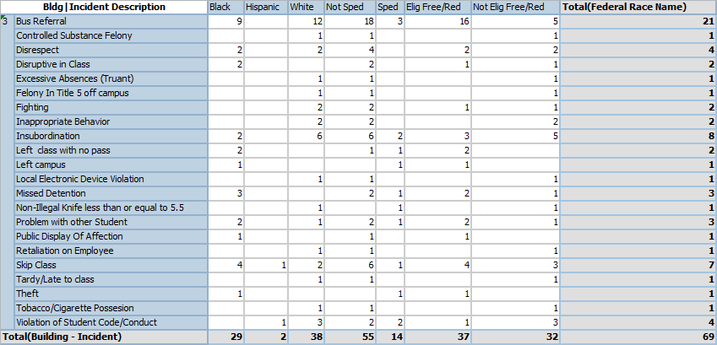
Questions:
What deductions can you make from disaggregating this data?
Which students are experiencing successes?
Which students are experiencing failures?
What is your biggest concern after reviewing the data?
What is one thing that you can do differently the 2nd 6 weeks to help students be successful?
Do you have questions that have been raised by looking at this data?

